Salad Container Greenhouses

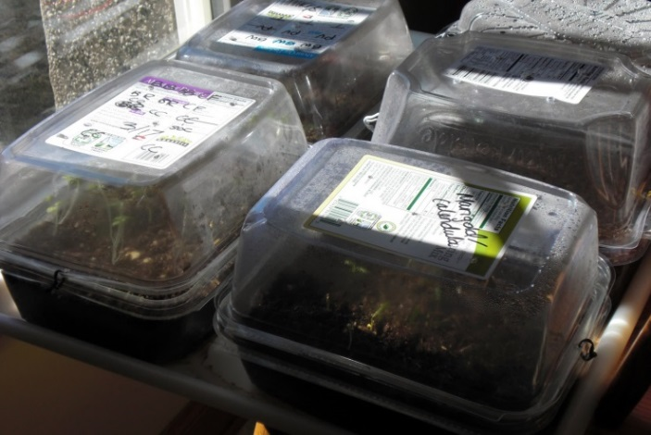
You will need:
One plastic salad container
1 sharpie Marker
seeds
Water mister
Plant label
Soil

Directions
- Get one plastic salad container.

- Write your name with a sharpie on the lid or the bottom. Decorate sides as desired

- Add soil to the container to within one-inch of the top.

- Choose seeds to sow in the container. Sow with depth and spacing according to the package directions.

- Water generously with the mister. Make sure the soil is nice and moist.

- Write a label for the container, cut if necessary to fit when lid is closed.

- Close lid and place in a sunny window. Water occasionally, not daily. Monitor daily for plant growth.

